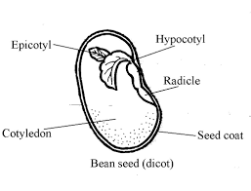
Seeds

You will need:
A Seed Science Experiment worksheet
A Pencil
2 pinto beans
A paper towel
A toothpick
A magnifying glass
A small Ziploc bag

Directions
- Remove the outside skin of one of the beans.
  - This part is called the seed coat, and it protects the bean inside.

- Place your fingernail at the rounded edge and spread the halves of each bean open lengthwise. Use a magnifying glass to look inside.

- Look at the cotyledon (cot-ee-lee-don). It is the largest part of the inside of the bean. It stores the food for the growing bean.

- At the top of the cotyledon is the shoot. Tease it out from the cotyledon with your toothpick.
There are three parts to the shoot.
- epicotyl (ep-ee-cot-ill) -This will form the bean’s future leaves.
- Just under the epicotyl is the hypocotyl (hippo-cot-ill) -This is the beginning of
the stem
- The radicle is under the hypocotyl - This is the beginning of the bean’s roots.

- Fold the paper towel and place it in the Ziploc bag.
- Put a row of staples across the bottom of the bag 1” up from the bottom.
- Place one whole seed and one embryo into the bag. Wet the paper towel with the spray bottles and leave the bag open. It should look like this:
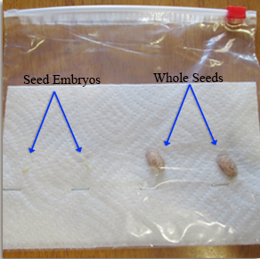
8. Fill out the Seed Science Experiment page.

